*Water Markets Decisions Regulations Discussion Paper*

*& Pre-trade Data Discussion Paper*

DRAFT 2 for member consultation

To the Department of Climate Change, Energy, Environment and Water

November 2024

Table of Contents

About us 1

Contact 2

Introduction 2

Background 2

Overview 2

General 1

Timeframe for commencement 1

Submission (i) – Water Market Decisions 2

Overview 2

1.1. What should be prescribed in the regulations as a ‘water markets decision’? 3

1.2. How should water markets decisions be announced? 7

1.3. If a person is providing a decision to the Bureau for publication as the means of first announcement, what details about the decision must be provided? 8

1.4. If a water markets decision is not provided to the Bureau for publication as the means of first announcement, what is to be reported to the Bureau and by when? 9

1.5. Manner or form for reporting decision information to the Bureau 9

1.6. What records are to be kept? 10

Submission (ii) – Pre-trade Market Information Data 11

Overview 11

Introduction 11

1.1 When will different service providers of online trading platforms be obligated to report pre-trade data to the Bureau? 13

1.2 When will de-identified pre-trade data from online trading platforms be published? 15

Conclusion 15

# About us

The National Irrigators’ Council (NIC) is the peak industry body for irrigated agriculture in Australia. NIC is the voice of irrigated agriculture and the industries producing food and fibre for domestic consumption and significant international trade. Put simply, our industry is helping to feed and clothe Australia and our trading partners.

Irrigated agriculture in Australia employs world leading practices in water management. Industry has extensively adopted and embraced new technologies and knowledge to ensure we are consistently growing more with less water. Australian farmers also operate under strict regulations and compliance mechanisms. These factors mean we lead the world in both farming practices and produce quality.

NIC’s policy and advocacy are dedicated to growing and sustaining a viable and productive irrigated agriculture sector in Australia. We are committed to the triple bottom line outcomes of water use - for local communities, the environment, and for our economy.

## Contact

Mrs. Zara Lowien, CEO

8/16 National Circuit, Barton, ACT 2600

ABN: 92 133 308 336

P: 02 6273 3637

E: [ceo@irrigators.org.au](mailto:ceo@irrigators.org.au)

W: [www.irrigators.org.au](http://www.irrigators.org.au)

X: @Nat_Irrigators

# Introduction

## Background

This public consultation comes as the Australian Government is developing regulations to enable operation of requirements in the new Part 5A and Part 7A to the Water Act 2007, relating to the announcement of ‘water markets decisions’ and ‘water market information’ respectively. This follows the *Water Amendment (Restoring Our Rivers) Act 2023* (RoR Act) in December 2023, and Part 5A is related to enabling and supporting the [Water Market Reform Roadmap](https://www.dcceew.gov.au/sites/default/files/documents/water-market-reform-final-roadmap-report.pdf).

This submission has been drafted to address questions within Discussion Papers for each component; Water Market Decisions and Pre-trade data for Water Market Information.

The water market decisions apply to Commonwealth agencies, Basin State agencies; or IIOs.

The water market information (pre-trade data), applies to any class of persons as outlined by the regulations, including water market intermediaries.

It is understood that once these obligations commence (1 July 2026), they will supersede the existing obligations under the Basin Plan which will cease.

## Overview

* NIC supports utmost transparency in the water market, but is concerned the proposals in these regulations go beyond the original intention of this reform, are not proportionate to the situation, by imposing significant regulatory burden, that outweighs the benefits. It is noted that the ACCC Inquiry which ignited this reform did not find any evidence of misconduct, rather, opportunity to strengthen the operations of the water market to ensure good governance. Given this, there are major concerns that these regulations have gone too far, and will be impractical and costly on IIOs, for little to no benefit.
* NIC is concerned by the overreach proposed in this reform, specifically in how Irrigation Infrastructure Operators (IIOs) are being treated in the same manner as Government agencies (despite very different functions, natures of market interactions, and information asymmetries), and, are being treated differently to other market participants (even when acting within an ordinary market participant capacity). There has been a longstanding principle that characteristics of a specified water right (entitlement) remain the same irrespective of who owns it (Government, an IIO, or an individual). There are concerns that under these regulations, different requirements are being put on users of the same water entitlements, going against this principle.
* NIC is concerned that the proposed regulatory approaches are subject to interpretation, and are not definitive, which will make implementation and enforcement challenging, due to a lack of clarity – this is very problematic where there are significant penalties for non-compliance. There are concerns regarding commercially sensitive information being published, which is not considered appropriate or acceptable.
* NIC notes that there is a series of reforms relating to the water market, to which these are just two components. These components (including what is considered proportionate and necessary) must be considered within the context of the full reform, and not in isolation.
* NIC notes the timeframe for commencement of these regulations is 1 July 2026, after the large-scale buybacks by the Federal Government, probably the largest market intervention in over a decade. It would be appropriate for the Federal Government to be at least acting within the spirit of these regulations, to demonstrate good market behavior and to trial the effectiveness of these provisions, in the meantime.

# General

## Timeframe for commencement

The timeframe for these regulations to commence is 1 July 2026.

It is noted that this is after the ongoing major water recovery efforts of the Federal Government.

Given the focus of the Discussion Paper on ‘increasing fair access to market sensitive information’, it is highly distasteful that the regulations only commence after these ongoing Federal Government interventions, which are the ultimate (and perhaps only major) example of misuse of market sensitive information on-scale.

While this date may be in the legislation, it would show good-faith for the Federal Government to be at least acting within the spirit of Part 5 in respecting the handling of market sensitive information.

Instead, we are seeing the Federal Government acting to the contrary. This has been confirmed by a recent report[1] by the Inspector-General of Water Compliance, which made some concerning findings about the handling of market sensitive information by DCCEEW.

Furthermore, the recent tender process has raised major concerns by stakeholders for impacts on water markets. Specifically, the tender documents said:

*‘Only respondents who submit an EOI in this first stage of the multi-stage procurement process are eligible and may be invited to participate in any subsequent requests for tender in 2025, arising from this EOI.’*

*‘Any response under this EOI is non-binding and considered to be an expression of interest only.’*

This concern from stakeholders such as NIC is that this approach will lead to false market signals via a hyper-inflated indication of buybacks interest, in turn, leading to artificially inflated prices. This is because many people will likely submit an EOI in order to keep the option open for the future, who may have little to no intent in actually participating, particularly depending on what the actual prices will be.

This concern was raised by NIC at the time:

*“The Federal Governments processes are inconsistent with their own water market reforms,”*

*“It’s unacceptable to tell people they must ‘get in now, or they’ll miss out’ when we know that is not how the process has to work but in doing so, the Federal Government becomes the ‘sole holder’ of the most comprehensive southern Basin water market information, at the exclusion of all others.”*

*“Most concerning, is this new announcement comes only weeks after a scathing report from the Inspector General of Water Compliance that called out the Federal Government for poor conduct in previous tender approaches.”*

*“Participants need to be confident this is a fair and equitable and that the Federal Government has processes to mitigate market shocks, manage sensitive information and provide good faith negotiations.”[2]*

It is within the context of these repeated and disturbing abuses of market sensitive information that this public consultation is occurring.

# Submission (i) – Water Market Decisions

## Overview

* + NIC is of the position that only market decisions that truly affect the market should be captured by the regulations, and is concerned the approaches proposed will go beyond this.
  + A key focus must be on how to determine the level of materiality of a decision to which this regulation should apply. NIC are concerned that the proposed approaches may lead to capturing a much greater range of water market decisions, which do not have a significant or material impact.
  + NIC is of the view that a threshold needs to be established to determine the degree of materiality which justifies a decision being captured by this regulation.
  + NIC is of the position that the proposed reporting approaches involve too much information, beyond what is required to achieve the objectives of the reform. Only the most absolutely necessary information should be required to be reported. It must be noted that there are already significant steps in place, and we don’t want to go backwards under these regulations.
  + NIC emphasizes the utmost importance of the timeliness of decision announcements, which should occur simultaneously to ensure fairness and equity, so that all parties become aware of the decision at the exact same point in time (i.e. the ‘reasonable period’ for the decision to be made generally available must be ‘simultaneously’ with no time lags.

Our key recommendation is the need to identify a threshold in the regulation to determine the level of materiality / significance of a decision that warrants being captured by the regulation, based on proportionality.

NIC also recommend that a more streamlined or bulk approach be developed to enable an IIO to establish and announce a ‘trading strategy’ to capture business as usual arrangements, and therefore only trade decisions outside the nominated trading strategy would then need to be announced (if considered ‘material’).

## 1.1. What should be prescribed in the regulations as a ‘water markets decision’?

**Background**

It is proposed to prescribe a decision in the regulations as a ‘water market decision’ if it:

“*relates to actions that a:*

* *Commonwealth agency,*
* *Basin State agency; or,*
* *IIO*

*is undertaking or may or will undertake, and*

* *is reasonably likely to influence persons who commonly acquire ETWRs in deciding whether or not to acquire or dispose of such rights, that is, it would have a material effect on the price or value of ETWRs, and*
* *is a decision which, if included in the regulations, would support the broader objectives and purpose of the new Part 5A.”*

It is noted in the Discussion Paper that while the term ‘material effect’ does not appear within the definition of ‘water markets decision’, it is defined in the legislation. The definition provides that for the purposes of the new Part 5A, a decision or information is taken to have a *material effect* on the price or value of an ETWR if the decision or information is reasonably likely to influence persons who commonly acquire ETWRs in deciding whether or not to acquire or dispose of such rights.

**Issue 1 – Materiality of the decision**

NIC is of the position that only decisions that significantly affect the market should be captured by the regulation.

The key consideration is that of materiality – i.e. which water market decisions are significant enough to have a material effect, that warrants it being captured by this regulation.

At present, the proposals in the discussion paper go beyond this (or at least are reasonably uncertain that they may be interpreted to go beyond this), and may lead to capturing a much greater range of water market decisions, which do not have a significant or material impact.

NIC is concerned by the risk that these regulations will lead to a significant regulatory, administrative and financial burden on IIOs, which in turn, poses time delays and a risk to efficient and effective operations. Ensuring the regulation is specific to only capturing those decisions which will have an actual material effect will be a critical step in ensuring the legislative objectives are met, but without unnecessary additional regulatory burden in going beyond the immediate objectives.

NIC is of the view that a threshold needs to be established to determine the degree of materiality which justifies a decision being captured by this regulation.

*Recommendation 1) Identify a threshold in the regulation to determine the level of materiality / significance of a decision that warrants being captured by the regulation, based on proportionality.*

There are a few important points to note in determining materiality.

1. The threshold must be clearly defined and quantified – the intent of the regulation (and legislation) appears to be to only capture material decisions, however, the language in the regulation is insufficiently clear to confidently determine what is captured, and what is not, which risks being interpreted to capture non-significant or non-material decisions. A clear, quantifiable, threshold is required to do this.
2. Since each market is different, the materiality of a decision will also differ between markets – therefore, any threshold to determine materiality would also need to be designed to factor this in. For this reason, we consider determining materiality based on proportionality would be the most suitable approach (as opposed to absolute numerical values). For example, materiality may be if greater than, say, 2-5% of average turnover in the market.

|  |
| --- |
| *Focus box: The problems with unclear language*  The language proposed in the Discussion Paper is open to interpretation as it lacks clarity (particularly where terms are difficult to identify/measure definitively).  While this may have some benefits for flexibility and managing on a case-by-case basis, the risk of this are that:   * understanding obligations and responsibilities will be difficult (which is very problematic where there are significant penalties for non-compliance); * implementation and enforcement will be challenging; * risks additional regulatory-burden beyond the intent of the legislation.   For example, while the definition of ‘material effect’ sounds appropriate conceptually, it will be challenging in practice because it will be very difficult to identify/measure definitively.  Specifically:   * there are many factors that would shape a decision of whether or not to acquire or dispose of such rights; * the term ‘influence’ is broad - almost any information would cause some degree of influence, the question is the significance of that influence; * the word ‘reasonable’ is also subject to a scale of ‘reasonableness’. What is considered ‘reasonable’ needs exploration, as well as consideration of whether reasonableness is different for different parties in different circumstances. |

**Issue 2 – Alternative process for business-as-usual decisions to minimize regulatory burden**

As above, NIC is concerned that these regulations will lead to a significant regulatory, administrative and financial burden on IIOs.

NIC sees opportunity to minimize regulatory burden and streamline requirements for instances where decisions may be considered ‘business as usual’ or standard operations, which could be reasonably expected to occur by the average market participant.

In these instances, a process whereby standard operations could be captured in bulk (i.e. such as publication of a document upfront), and only the abnormal or non-standard decisions would need to follow these requirements.

This would significantly reduce the regulatory impact (given many of these standard decisions occur at high frequency), and would be low impact given these decisions are typically reasonably expected.

*Recommendation 2) Create a bulk or fast-track process for business as usual or standard operations decisions to reduce regulatory burden.*

**Issue 3 – Staying within the legislative intent**

NIC is concerned that the proposals in the Discussion Paper are moving beyond what was intended by the reform (and legislation). NIC emphasize the importance of remaining focused on the core objectives of the reform, and that additional regulatory requirements are unnecessary.

The list of decisions in the Discussion Paper (copied below) should be reviewed with this in mind, asking the question – what is actually required?

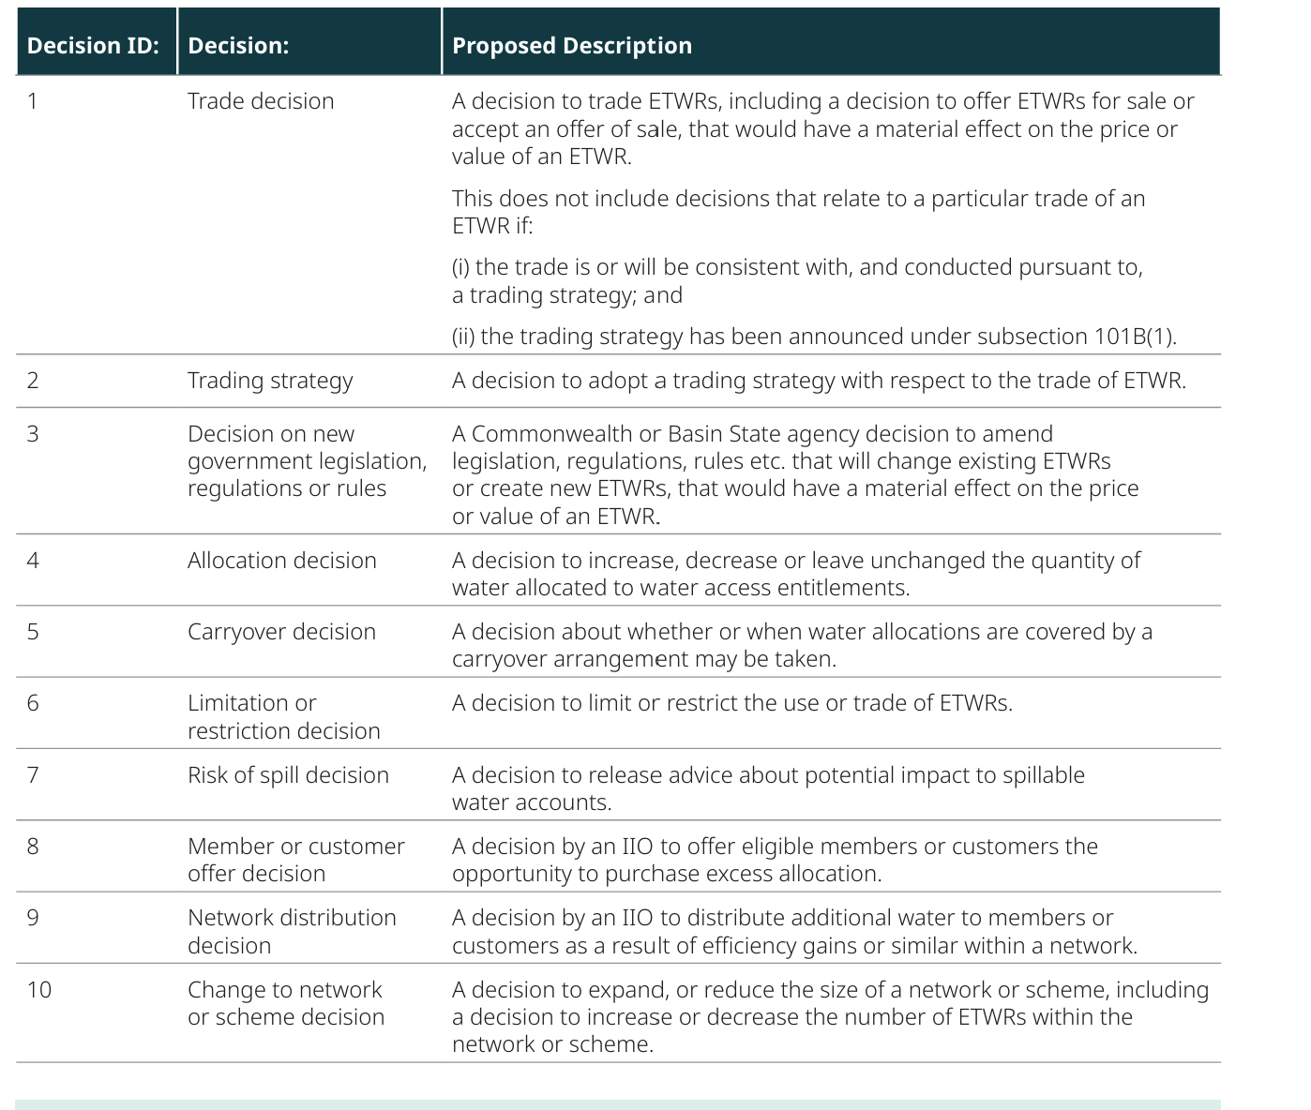

To streamline processes and requirements, NIC recommends that a pathway be established for the IIO to establish and announce a trading strategy under Decision ID 2 at the start of the water year, and therefore only trade decisions (Decision ID 1) outside the nominated trading strategy would then need to be announced (if considered ‘material’).

This means the following Decision IDs do not apply to IIOs: 3, 4, 5, 6, 7, 10 (noting 8 and 9 would be covered by the trading strategy (ID 2), or a trade decision (ID 1).

The following Decision IDs do apply to Government agencies: 1. 2, 3, 4, 5, 6, 7.

NIC recommends Decision ID 10 is omitted as it is not relevant.

NIC also notes that a Government decision to change a process, which may impact accessibility, such as for IVT changes, must be announced to all market participants (not just the States) to overcome equity issues of some States being more efficient in notifying users.

NIC recommends clarification is required on the following (with potential for it also to be omitted):

* Decision ID 6 – what is this intended to capture?
* Decision ID 2 – what is the reason for needing to capture this, and how will commercially sensitive information be managed?

*Recommendation 3) Remove any ‘decisions’ or subsequent requirements that are not directly required by the legislation, nor within the immediate focus of the reform*

**Issue 4 – Distinguishing between Government and IIO decisions, based on role/function**

The above list of potential water market decisions merges decisions within the capacity of Government, and those of IIOs. It must be noted that IIOs do not have the same powers, information-access, level of influence / impact, or resourcing capacity as Government agencies, and it is highly questionable that IIOs are captured within the same requirements as Government agencies.

Consideration should be given to whether decisions by IIOs require the same approaches as decisions by Government agencies. This should be considered with a risk-based approach, with consideration also to the resourcing capacity.

A further consideration must be under what circumstances is an IIO considered to be acting as an IIO, as opposed to acting as any other market participant. It is not considered to be appropriate, or within scope, for all decisions by an IIO to be captured, rather just those that involve decision-making or functions beyond those of the standard market participant.

*Recommendation 4) Separate decisions by Government agencies, to those of IIOs, and consider whether some decisions require different requirements based on risk-level and reasonable resourcing capacity.*

*Recommendation 5) Exempt certain decisions by IIOs that are not considered to be within scope of this reform*

To address many of the issues raised in this submission, another approach can be to insert a mechanism into the regulation to exempt certain decisions by IIOs that are not considered to be within scope of this reform.

NIC heard mention of potential exemptions at the webinar, but notes these are not clear in the Discussion Paper. Further clarification is required on what these are, and how they will operate.

Examples of what NIC considers as items to be exempt are where decisions are:

* Minor or insignificant (noting these are currently captured by the definition in the absence of clear thresholds)
* Outside the scope of the immediate objectives of this reform (i.e. delivery rights)
* Unreasonable or ineffective, such as highly frequent occurrences or where the regulatory burden outweighs the benefits
* Where the IIO is acting as a typical market participant with no decision-making capacity of information asymmetry
* Business-as-usual or standard operations, in that they could be reasonably expected to occur by the average market participant
* Commercial-in-confidence.

There are a range of mechanisms for how this could occur in the regulations:

|  |  |
| --- | --- |
| Reason for exemption | Suggested regulatory mechanism |
| Minor or insignificant (noting these are currently captured by the definition in the absence of clear thresholds) | Establish a threshold to shape the degree of ‘influence’ that is considered to warrant triggering these provisions, i.e. to exclude minor and insignificant decisions. |
| Business-as-usual or standard operations, in that they could be reasonably expected to occur by the average market participant | Amend definition to include ‘outside of standard operations’.  Or, enable IIOs to publish a document of business-as-usual or standard operations approaches in bulk, to which only the out-of-the-ordinary or unexpected decisions need to undergo these processes. |
| Outside the scope of the immediate objectives of this reform | Amend the list of suggested decisions to be targeted to only the central matters, and omit the others (i.e. delivery rights, change to network or scheme decision, network distribution decisions, and member or customer offer decisions) |
| Unreasonable or ineffective, such as highly frequent occurrences or where the regulatory burden outweighs the benefits | Insert an exemption for certain decisions, such as those that would require reporting several times a day (consult with IIOs for specifics). |
| Where the IIO is acting as a typical market participant | Remove / exempt ‘decisions’ where the IIO is acting as a typical market participant, i.e. with no management or rule-making function |
| Commercial-in-confidence | Amend the list of suggested decisions to exclude commercially sensitive decisions, or at least, for commercially sensitive information to not be included within the reporting. |

Member feedback sought – what are some examples of exemptions in other markets that could be used as a precedence / example of what we may be seeking?

**Other**

*Recommendation 6) Clarify that if the IIO is just passing on a decision from the State Government agency, this doesn't need to be announced by the IIO, as it is not a new decision, and only needs to be announced once.*

*Recommendation 7) Ensure no backwards steps from existing water announcement obligations under the Basin Plan which will cease on 1 July 2026 when these regulations commence.*

## 1.2. How should water markets decisions be announced?

**Background**

Section 101B(1) of the new Part 5A to the Water Act will require a person who makes a water markets decision to ensure that water markets decisions are first announced by one of two methods:

Method 1: The decision is provided to the Bureau for the purpose of publication, or–

Method 2: The decision is first announced in a manner prescribed by the regulations (and then reported to the Bureau).

**Position**

* A ‘reasonable period’ for the decision to be made generally available must be “simultaneously” – i.e. to execute the responsibility at the same time. This is critical to ensure fairness and equity, so that all parties become aware of the decision at the exact same point in time.
* It must be noted that there are already significant steps in place for this, and we don’t want to go backwards under these regulations.

Member feedback sought – are you able to provide a ‘case study’ of current process, to assist in demonstrating status quo, not wanting to go backwards, and need to streamline.

## 1.3. If a person is providing a decision to the Bureau for publication as the means of first announcement, what details about the decision must be provided?

**Background**

**Position**

* NIC is of the position that the details of what needs to be included in the announcement don’t need to be prescribed to this level of detail, as this will be overly prescriptive for the regulation.
* The proposed details are too much information, and goes beyond what is required to achieve the objectives of the reform.
* Only the most absolutely necessary information should be required to be reported, but this does not need to be inserted into regulation.
* There are concerns regarding commercially sensitive information being published.
* The ‘methodology’ in particular needs to be omitted, and is not considered relevant.
* It is assumed that the name and contact details are of the entity, not an individual, but this needs clarifying to ensure privacy is protected.

*Recommendation 8) Do not include the details of what needs to be included in the announcement in the regulation itself, as it is overly prescriptive*

Member feedback sought – is there any further information in the above which we would like to exclude?

## 1.4. If a water markets decision is not provided to the Bureau for publication as the means of first announcement, what is to be reported to the Bureau and by when?

**Background**

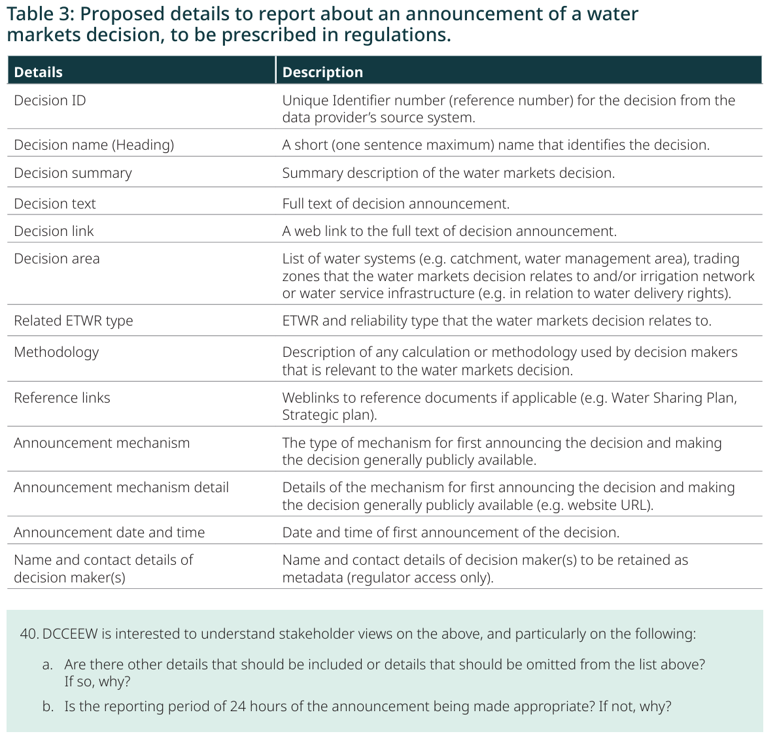

**Position**

See 1.3.

## 1.5. Manner or form for reporting decision information to the Bureau

**Background**

The Bureau is developing a new Water Data Hub which will allow for secure provision of water markets decision information. The Water Data Hub will accommodate several methods for provision of data (manner of provision) via an online data provider portal, which are expected to include:

1. a form or capacity for manual file upload

2. API interface

3. Secure File Transfer Protocol (SFTP).

The form or format of the water markets decision information will need to be such that it can be automatically ingested by the Water Data Hub, appropriate to the manner of provision.

Email not currently considered.

**Position**

* The manner for reporting should capture existing information channels, such as emails where IIOs notify customers of decisions. This would help alleviate the regulatory burden, and ensure notification occurs simultaneously with all parties.
* A central hub is considered to be unnecessary given there are multiple water markets which makes one central site null and void, and users are concerned by the cost implications of this.
* A backup system needs to be available for instances where this site may crash or be malfunctioning, such as an email option.

*Recommendation 9) Enable existing forms of reporting to be used, including email.*

## 1.6. What records are to be kept?

**Background**

|  |  |
| --- | --- |
| **Legislation** | **Regulation (proposed)** |
| A person who makes a water markets decision will be required to keep the following records in relation to the decision for at least 5 years commencing on the water markets decision date:   1. The fact that the water markets decision was made and the date on which it was made (section 101C(1)(a)), 2. If the water markets decision was provided to the Bureau under section 101B(1)(a) – all the details provided, and the date and time on which the water markets decision was provided (section 101C(1)(b)), 3. If the water markets decision was not announced under section 101B(1)(a) – the date, time, manner and content of the announcement of the water markets decision (section 101C(1)(c)), and 4. any other information as is prescribed by the regulations (section 101C(1)(d)). | It is proposed to also include in the regulations records of the following:   * The name of the person that made the water markets decision, and * If the water markets decision was not announced under section 101B(1)(a):   – all information which is required to be reported, and is reported to the Bureau under section 101B(3), and  – if not otherwise prescribed under Regulations for the purposes of section 101B(3), the date and time on which the decision was reported to the Bureau and the name of the person that reported it. |

**Position**

* Clarify if ‘name of the person’ should be ‘name of the entity’, as a personal names pose privacy concerns.
* See positions for previous sections.

# Submission (ii) – Pre-trade Market Information Data

## Overview

* NIC is concerned that the pre-trade data requirements are unrealistic and provide little benefit to market participants. There are market risks with unfettered pre-trade data being reported that must be considered properly before finalising the regulations. Pre-trade data is not always accurate market information and adds additional complexity with questionable value to the market participant (particularly if inaccurate).
* Further refinement to the definition of pre-trade data, and the class or persons, is required to avoid market risks and ensure that the reporting adds to the transparency and integrity of the water market.

## Introduction

The RoR Act provides the following definition for pre-trade data:

*“****pre-trade****, in relation to the trade or transfer, or proposed trade or transfer, of any type of eligible tradeable water right includes, but is not limited to, offers to buy or sell occurring before an agreement or contract for the trade or transfer is entered into.”*

The ACCC identified that pre-trade data could improve market transparency and ensure intermediaries could act with the interests of their clients, and investigate market manipulation but also noted:

*“nor would it be possible to impose such a requirement because there are many trades negotiated without the use of platforms or brokers. While the use of exchange platforms may increase over time, many traders are family farms who see value in maintaining simpler or less formal entry points into water markets.”*[3]

The ACCC recognise there are key barriers to collecting pre-trade data that undermine the integrity of the data and its usefulness to address concerns. These barriers, limit the scope of pre-trade data being collected, which undermines the effectiveness of the data to be used to investigate potential market manipulation which is another driver for the data. As not all pre-trades eventuate into a formal trade for a range of reasons. This means that some pre-trade data could provide less accurate data about the market, undermining the overarching outcome to provide greater accuracy and build market trust and confidence.

Given the barriers and potential implications regarding pre-trade data, the ACCC recommended to include obligations to act in good faith, as now determined through the Intermediaries Code Policy Position and market manipulation prohibitions, rather than pursuing specific pre-trade data requirements comparable to the Australian Financial system requirements.

Whilst the ACCC raised concerns about the quality of water market information and timeliness, this issue appears to have been conflated into unrealistic requirements for the collection of near real-time pre-trade data for both the selling and potential offers from a sub-section of water market contributors as proposed in the roadmap.

Other reform elements, already initiated, including the requirement to enter a trade price will provide the much-needed transparency and integrity required and improve accuracy of the data. Furthermore, record keeping requirements and the ACCC investigative powers provide an opportunity for interrogation of data, without the need for uploads to the Bureau.

NIC acknowledges there does remain an ‘information gap’ between the striking of an agreement between parties (matching of an offer) and the completion of the trade, which can vary between jurisdictions, intermediaries and IIOs. This should be the priority for improving information, rather than a collection of pre-trade data from some platforms which may or may not eventuate in a formal trade.

Reducing the processing times for trades would immediately reduce the information gap on price, by ensuring the reported market information is as contemporary as possible.

Furthermore, if market depth is an integral concern as mentioned in the roadmap, then the priority should be in providing the appropriate links from the Bureau portal to the platforms with available water. This allows participants to navigate to the source, noting that the Bureau platform will not be an exchange rather a source of truth for data. This allows participants to have direct access.

**Case Study: Pre-trade data requirements and 2023 Bridging the Gap Tenders.**

It’s acknowledged that the majority of market reforms will not apply by the completion date of the Murray Darling Basin Plan. A review of market interactions by the Commonwealth in the 2023 Bridging the Gap purchases, highlight a number of unintended consequences that must be considered when finalising the requirements for pre-trade data reporting.

The Australian Government announced the intention to ‘Bridge the Gap’ via tenders from willing participants in remaining Murray Darling Basin catchments, where the Sustainable Diversion Limit had not been achieved.

These tenders opened on 23 March 2023 and closed on 19 May 2023 via AusTender, an electronic platform of sorts for receiving offers.

On 31 October 2023[4], the Minister for Water announced that offers were received for twice the volume of water required by the tenders.

On 15 February 2024, the Minister announced that 26.25GL was likely to be contracted but further work was ongoing[5] and the 2023 program was finalised and updated, for a new 2024 Strategy (for the revised Gap and locations).

The Australian Government confirmed at Senate Estimates on 8th November 2024, that they had rejected more than 72% of the offers largely due to value for money concerns, with the final contract volume 26.25GL.

It is assumed that the price requested for the majority of the offers was over-and-above the price willing to be paid or considered comparable to the current market price to meet value for money under Commonwealth procurement.

‘Offers’ (even unsuccessful ones) are defined as pre-trade data in the RoR Act, without the definition being limited in the regulations this would mean these offers are considered pre-trade data. In the case of the Bridging the Gap tenders, 72% of the reported pre-trade data would not have eventuated in an offer and would have resulted in incorrect market signals of presumably, elevated prices, which would have had material market implications that would have taken over-twelve months to correct via confirmed contracts and trades.

The current Discussion Paper proposes pre-trade data initially from live matched platforms and then intermediaries with online platforms which may not necessarily include the AusTender platform.

This subsequently raises questions then about the purpose and use of the pre-trade data, when one the largest potential participants, the Australian Government is excluded from the requirements and whether the requirement, will disadvantage platforms who have to report the information, resulting in participants and intermediaries opting for manual operations to avoid data capture.

The NIC is concerned that the pre-trade data requirements is not fit for purpose for issue it is being designed to address. The provision of unfettered, pre-trade data for buy or sell offers presents significant market risks that do not appear to have been considered. Pre-trade data is not always accurate market information and adds additional complexity with questionable value to the market participant (particularly if inaccurate). The reporting of inaccurate data would have water market implications, depending on the scale and timing of the data and the ability for any participant to interrogate the accuracy of pre-trade against final trade data.

The current proposal means that the pre-trade data will be limited in scope, excluding any private arrangements and any offline options. An unintended consequence of this requirement will see some institutions moving to manual systems, which would have impacts on other elements of the reform.

These risks must be considered prior to finalising the policy position, to ensure that the regulation settings remain fit for purpose and are aligned to the overarching objective of the reforms – to improve transparency, integrity and accountability in the water markets.

NIC considers that the best focus of the reform should consider how to reduce processing time in the first instance to ensure timeliness of data.

We recommend that ‘pre-trade’ information is further defined and have comments specific to the next section.

*Recommendation 10) The Department should consider ways to incentivize water market authorities to reduce processing times, to reduce the time between pre-trade data and water market data.*

## 1.1 When will different service providers of online trading platforms be obligated to report pre-trade data to the Bureau?

As outlined above, we recommend that further information to define pre-trade data is undertaken, beyond live matching platforms and online intemedaries as proposed by the paper.

NIC recommends that ‘pre-trade’ is more clearly defined in the regulations to be measured at the point at which an offer is accepted, and the application process commences, rather than an open definition of offer during a negotiating period. This aims to address the considerable market information risks posed by poorly informed ‘pre-trade data’ as presented within the case study by:

* Increasing the likelihood of the pre-trade data becoming directly matched trade data and therefore, a truer record of the market.
* Reduces the complexity of water market information, as pre-trade data is more likely to be superseded by actual trade data which is already required to be reported.
* Effectively expands the volume of trades that pre-trade data is collected from without the need for additional data collection as the ‘strike date’ is now a requirement on all trade forms, whether manual or online trading systems are used or even private one-to-one arrangements.

The paper proposed the following staging of pre-trade data requirements:

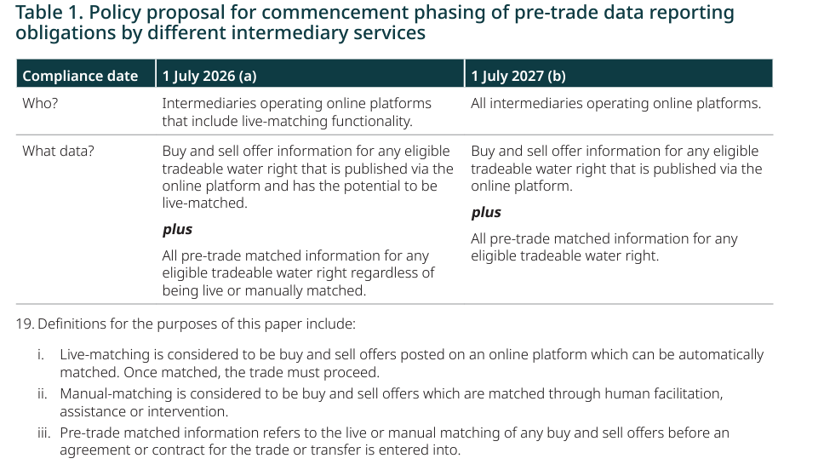

As raised earlier, the NIC is concerned about the unintended consequences of misleading pre-trade data being automatically reported regardless of the timing of the staging approach.

We, therefore, suggest that the initial data requirements are refined for pre-trade data to be considered as any matched data where a deal is to be struck to be provided using the strike date as the date by which the pre-trade data should be provided to the Bureau by 1 July 2026. Other reporting requirements are to be delayed until the risks are addressed.

*Recommendation 11) pre-trade data should be clarified to be defined at the point an offer is accepted and progressed to a water trade application, essentially the strike date by 1 July 2026.*

Member feedback on if this is achievable and reasonable suggestion.

Live matched platforms and online platforms should be encouraged to maintain and display pre-trade data where possible, but this is not a reportable requirement. Where pre-trade data is displayed electronically, a record should be maintained to provide a data source for the ACCC if required to investigate any market manipulation concerns.

We also recommend an exemption for pre-trade data on parcels less than 10ML to not be required to be reported.

Member feedback sort here on the exemption threshold.

*Recommendation 12) exemption for pre-trade data on all parcels less than 10ML to not be reported to Bureau or publicly reportable.*

Further refinements will be required for later implementation on 1 July 2027 to ensure the integrity of pre-trade data being requested. This could include:

* Notifying the Bureau of the volume of water available (buy or sell), not price.
* Providing links to platforms where water is available.

These steps aim to provide a broader picture of the market depth and encourage participation without displaying misleading information on an official Government website. The above requirements could apply to all intermediaries.

*Recommendation 13) all intermediaries to report to inform the Bureau of available water with a link back to their platform or systems by 1 July 2027.*

## 1.2 When will de-identified pre-trade data from online trading platforms be published?

As per the above, we recommend caution regarding the publication of pre-trade data that may be misleading or have unintended consequences.

We therefore support the staging of data reporting as provided in the discussion paper and in particular, consideration of how market participants can understand what water is available and on what platform, and that a link is provided back to the platform.

*Recommendation 14, reporting to commence on 1 July 2027 with links from the Bureau to any platforms with water for sale.*

We recommend an exemption for pre-trade data on parcels less than 10ML to not be required to be reported.

# Conclusion

NIC welcomes this public consultation on the regulations to enable operation of requirements in the new Part 5A and Part 7A to the Water Act 2007, relating to the announcement of ‘water markets decisions’ and ‘pre-trade data’ requirements.

Overall, NIC is concerned that these regulations go beyond the regulatory-need and impose a significant regulatory-burden that outweighs the benefits, presenting unintended consequences that may undermine the overall objective of the reforms.

While NIC supports utmost transparency and fair market participation, this regulation is not fit-for-purpose as it goes beyond what is considered reasonable, is unclear, and is not a proportionate response.

NIC welcomes further consultation on a new version that meets legislative requirements in a fair, reasonable and proportionate manner.

**Ends.**

Member feedback sought – any other issues, comments or recommendations.

1. [Audit - Controls Supporting Compliance with Basin Plan Requirements](https://www.igwc.gov.au/sites/default/files/2024-09/controls-supporting-compliance-basin-plan-requirements.pdf)
2. [Buyback round designed to over-estimate interest ahead of election | National Irrigators' Council](https://www.irrigators.org.au/buyback-round-designed-to-over-estimate-interest-ahead-of-election/)
3. Page. 272 ACCC Water Market Inquiry, 2021 www.accc.gov.au/system/files/Murray-Darling%20Basin%20-%20water%20markets%20inquiry%20-%20Final%20report_0.pdf
4. https://minister.dcceew.gov.au/plibersek/media-releases/positive-response-governments-voluntary-water-tender-process
5. https://minister.dcceew.gov.au/plibersek/media-releases/offers-flow-government-purchases-water-murray-darling-basin