*Water Markets Decisions Regulations Discussion Paper*

DRAFT for member consultation

To the Department of Climate Change, Energy, Environment and Water

November 2024

Table of Contents

About us 1

Contact 1

Introduction 1

Background 1

Overview 1

Submission 2

1.1. What should be prescribed in the regulations as a ‘water markets decision’? 2

Unclear language 4

1.2. How should water markets decisions be announced? 5

1.3. If a person is providing a decision to the Bureau for publication as the means of first announcement, what details about the decision must be provided? 5

1.4. If a water markets decision is not provided to the Bureau for publication as the means of first announcement, what is to be reported to the Bureau and by when? 6

1.5. Manner or form for reporting decision information to the Bureau 7

1.6. What records are to be kept? 8

General 8

Timeframe for commencement 8

Conclusion 9

# About us

The National Irrigators’ Council (NIC) is the peak industry body for irrigated agriculture in Australia. NIC is the voice of irrigated agriculture and the industries producing food and fibre for domestic consumption and significant international trade. Put simply, our industry is helping to feed and clothe Australia and our trading partners.

Irrigated agriculture in Australia employs world leading practices in water management. Industry has extensively adopted and embraced new technologies and knowledge to ensure we are consistently growing more with less water. Australian farmers also operate under strict regulations and compliance mechanisms. These factors mean we lead the world in both farming practices and produce quality.

NIC’s policy and advocacy are dedicated to growing and sustaining a viable and productive irrigated agriculture sector in Australia. We are committed to the triple bottom line outcomes of water use - for local communities, the environment, and for our economy.

## Contact

Mrs. Zara Lowien, CEO

8/16 National Circuit, Barton, ACT 2600

ABN: 92 133 308 336

P: 02 6273 3637

E: [ceo@irrigators.org.au](mailto:ceo@irrigators.org.au)

W: [www.irrigators.org.au](http://www.irrigators.org.au)

X: @Nat_Irrigators

# Introduction

## Background

This public consultation comes as the Australian Government is developing regulations to enable operation of requirements in the new Part 5A to the Water Act 2007, relating to the announcement of ‘water markets decisions’. This follows the *Water Amendment (Restoring Our Rivers) Act 2023* (RoR Act) in December 2023, and Part 5A is related to enabling and supporting the [Water Market Reform Roadmap](https://www.dcceew.gov.au/sites/default/files/documents/water-market-reform-final-roadmap-report.pdf).

This section applies to Commonwealth agencies, Basin State agencies; or IIOs.

It is understood that once these obligations commence (1 July 2026), they will supersede the existing water announcement obligations under the Basin Plan which will cease.

## Overview

* NIC supports utmost transparency in the water market, but is concerned the proposals in this regulation go beyond the original intention of this reform, are not proportionate to the situation, and impose significant regulatory burden, that outweighs the benefits. It is noted that the ACCC Inquiry which ignited this reform did not find any evidence of misconduct, rather, opportunity to strengthen the operations of the water market to ensure good governance. Given this, there are major concerns that these regulations have gone too far, and will be impractical and costly on IIOs, for little to no benefit.
* NIC is concerned by the overreach proposed in this reform, specifically in how Irrigation Infrastructure Operators (IIOs) are being treated in the same manner as Government agencies (despite very different functions, natures of market interactions, and information asymmetries), and, are being treated differently to other market participants (even when acting within an ordinary market participant capacity). There has been a longstanding principle that characteristics of a specified water right (entitlement) remain the same irrespective of who owns it (Government, an IIO, or an individual). There are concerns that under these regulations, different requirements are being put on users of the same water entitlements, going against this principle.
* NIC is of the position that only decisions that truly affect the market should be captured by this regulation, and is concerned the approaches proposed will go beyond this.
* NIC recommends that a mechanism is inserted into the regulation to exempt certain decisions by IIOs that are not considered to be within scope of this reform, such as, where decisions are:
* Minor or insignificant (noting these are currently captured by the definition in the absence of clear thresholds)
* Outside the scope of the immediate objectives of this reform (i.e. delivery rights, change to network or scheme decision, network distribution decisions, and member or customer offer decisions)
* Unreasonable or ineffective, such as highly frequent occurrences or where the regulatory burden outweighs the benefits
* Business-as-usual or standard operations, in that they could be reasonably expected to occur by the average market participant
* Commercial-in-confidence.
* NIC is concerned that the proposed regulatory approaches are subject to interpretation, and are not definitive, which will make implementation and enforcement challenging, due to a lack of clarity – this is very problematic where there are significant penalties for non-compliance.
* NIC emphasizes the utmost importance of the timeliness of decision announcements, which should occur simultaneously to ensure fairness and equity, so that all parties become aware of the decision at the exact same point in time (i.e. the ‘reasonable period’ for the decision to be made generally available must be ‘simultaneously’ with no time lags.
* It must be noted that there are already significant steps in place, and we don’t want to go backwards under these regulations.
* NIC is of the position that the proposed reporting approaches involve too much information, beyond what is required to achieve the objectives of the reform. Only the most absolutely necessary information should be required to be reported.
* There are concerns regarding commercially sensitive information being published, which is not considered appropriate or acceptable.
* NIC notes the timeframe for commencement of these regulations is 1 July 2026, after the large-scale buybacks by the Federal Government, probably the largest market intervention in over a decade. It would be appropriate for the Federal Government to be at least acting within the spirit of these regulations, to demonstrate good market behavior and to trial the effectiveness of these provisions, in the meantime.

# Submission

## 1.1. What should be prescribed in the regulations as a ‘water markets decision’?

**Background**

It is proposed to prescribe a decision in the regulations as a ‘water market decision’ if it:

“*relates to actions that a:*

* *Commonwealth agency,*
* *Basin State agency; or,*
* *IIO*

*is undertaking or may or will undertake, and*

* *is reasonably likely to influence persons who commonly acquire ETWRs in deciding whether or not to acquire or dispose of such rights, that is, it would have a material effect on the price or value of ETWRs, and*
* *is a decision which, if included in the regulations, would support the broader objectives and purpose of the new Part 5A.”*

It is noted in the Discussion Paper that while the term ‘material effect’ does not appear within the definition of ‘water markets decision’, it is defined in the legislation. The definition provides that for the purposes of the new Part 5A, a decision or information is taken to have a *material effect* on the price or value of an ETWR if the decision or information is reasonably likely to influence persons who commonly acquire ETWRs in deciding whether or not to acquire or dispose of such rights.

**Position**

NIC is of the position that only decisions that truly affect the market should be captured by the regulation.

At present, the proposals in the discussion paper go beyond this. NIC is concerned by the risk that these regulations will lead to a significant regulatory, administrative and financial burden on IIOs, which in turn, poses time delays and a risk to efficient and effective operations.

NIC **recommends** that a mechanism is inserted into the regulation to exempt certain decisions by IIOs that are not considered to be within scope of this reform, such as, where decisions are:

* Minor or insignificant (noting these are currently captured by the definition in the absence of clear thresholds)
* Outside the scope of the immediate objectives of this reform (i.e. delivery rights)
* Unreasonable or ineffective, such as highly frequent occurrences or where the regulatory burden outweighs the benefits
* Where the IIO is acting as a typical market participant
* Business-as-usual or standard operations, in that they could be reasonably expected to occur by the average market participant
* Commercial-in-confidence.

Member feedback sought – what are some examples of exemptions in other markets that could be used as a precedence / example of what we may be seeking?

There are a range of mechanisms for how this could occur in the regulations:

|  |  |
| --- | --- |
| Reason for exemption | Suggested regulatory mechanism |
| Minor or insignificant (noting these are currently captured by the definition in the absence of clear thresholds) | Establish a threshold to shape the degree of ‘influence’ that is considered to warrant triggering these provisions, i.e. to exclude minor and insignificant decisions. |
| Business-as-usual or standard operations, in that they could be reasonably expected to occur by the average market participant | Amend definition to include ‘outside of standard operations’.  Or, enable IIOs to publish a document of business-as-usual or standard operations approaches in bulk, to which only the out-of-the-ordinary or unexpected decisions need to undergo these processes. |
| Outside the scope of the immediate objectives of this reform | Amend the list of suggested decisions to be targeted to only the central matters, and omit the others (i.e. delivery rights, change to network or scheme decision, network distribution decisions, and member or customer offer decisions) |
| Unreasonable or ineffective, such as highly frequent occurrences or where the regulatory burden outweighs the benefits | Insert an exemption for certain decisions, such as those that would require reporting several times a day (consult with IIOs for specifics). |
| Where the IIO is acting as a typical market participant | Remove / exempt ‘decisions’ where the IIO is acting as a typical market participant, i.e. with no management or rule-making function |
| Commercial-in-confidence | Amend the list of suggested decisions to exclude commercially sensitive decisions, or at least, for commercially sensitive information to not be included within the reporting. |

The list of potential decisions to include are in the Discussion Paper (copied below).

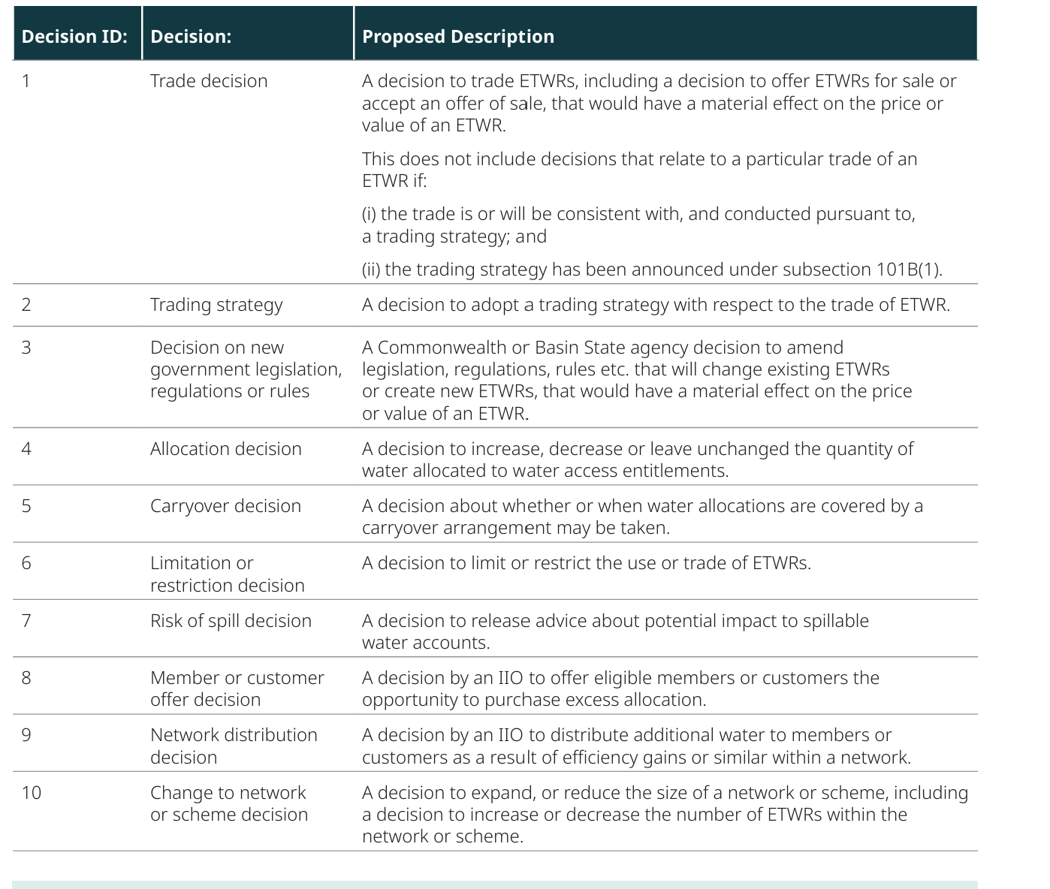

NIC recommends the following are omitted because they are not relevant or are insignificant, as they are separate from market interactions:

* Decision ID 10
* Decision ID 9
* Decision ID 8

NIC recommends clarification is required on:

* Decision ID 6 – what is this intended to capture?
* Decision ID 2 – what is the reason for needing to capture this, and how will commercially sensitive information be managed?

Member feedback sought – which decisions from the above table do we consider acceptable for inclusion, and not?

A further consideration must be under what circumstances is an IIO considered to be acting as an IIO, as opposed to acting as any other market participant. It is not considered to be appropriate, or within scope, for all decisions by an IIO to be captured, rather just those that involve decision-making or functions beyond those of the standard market participant.

### Unclear language

The language proposed in the Discussion Paper is open to interpretation as it lacks clarity (particularly where terms are difficult to identify/measure definitively). While this may have some benefits for flexibility and managing on a case-by-case basis, it will mean:

* understanding obligations and responsibilities will be difficult (which is very problematic where there are significant penalties for non-compliance);
* implementation and enforcement will be challenging.

For example, while the definition of ‘material effect’ sounds appropriate conceptually, it will be challenging in practice because it will be very difficult to identify/measure definitively. Specifically:

* there are many factors that would shape a decision of whether or not to acquire or dispose of such rights;
* the term ‘influence’ is broad - almost any information would cause some degree of influence, the question is the significance of that influence;
* the word ‘reasonable’ is also subject to a scale of ‘reasonableness’. What is considered ‘reasonable’ needs exploration, as well as consideration of whether reasonableness is different for different parties in different circumstances.

On balance, should regulations of this kind progress, greater clarity will be needed to ensure obligations and responsibilities can be clearly understood.

## 1.2. How should water markets decisions be announced?

**Background**

Section 101B(1) of the new Part 5A to the Water Act will require a person who makes a water markets decision to ensure that water markets decisions are first announced by one of two methods:

Method 1: The decision is provided to the Bureau for the purpose of publication, or–

Method 2: The decision is first announced in a manner prescribed by the regulations (and then reported to the Bureau).

**Position**

* A ‘reasonable period’ for the decision to be made generally available must be “simultaneously” – i.e. to execute the responsibility at the same time. This is critical to ensure fairness and equity, so that all parties become aware of the decision at the exact same point in time.
* It must be noted that there are already significant steps in place for this, and we don’t want to go backwards under these regulations.

Member feedback sought – are you able to provide a ‘case study’ of current process, to assist in demonstrating status quo, not wanting to go backwards, and need to streamline.

## 1.3. If a person is providing a decision to the Bureau for publication as the means of first announcement, what details about the decision must be provided?

**Background**

**Position**

* NIC is of the position that this is too much information, and goes beyond what is required to achieve the objectives of the reform.
* Only the most absolutely necessary information should be required to be reported.
* There are concerns regarding commercially sensitive information being published.
* The ‘methodology’ in particular needs to be omitted, and is not considered relevant.
* It is assumed that the name and contact details are of the entity, not an individual, but this needs clarifying to ensure privacy is protected.

Member feedback sought – is there any further information in the above which we would like to exclude?

## 1.4. If a water markets decision is not provided to the Bureau for publication as the means of first announcement, what is to be reported to the Bureau and by when?

**Background**

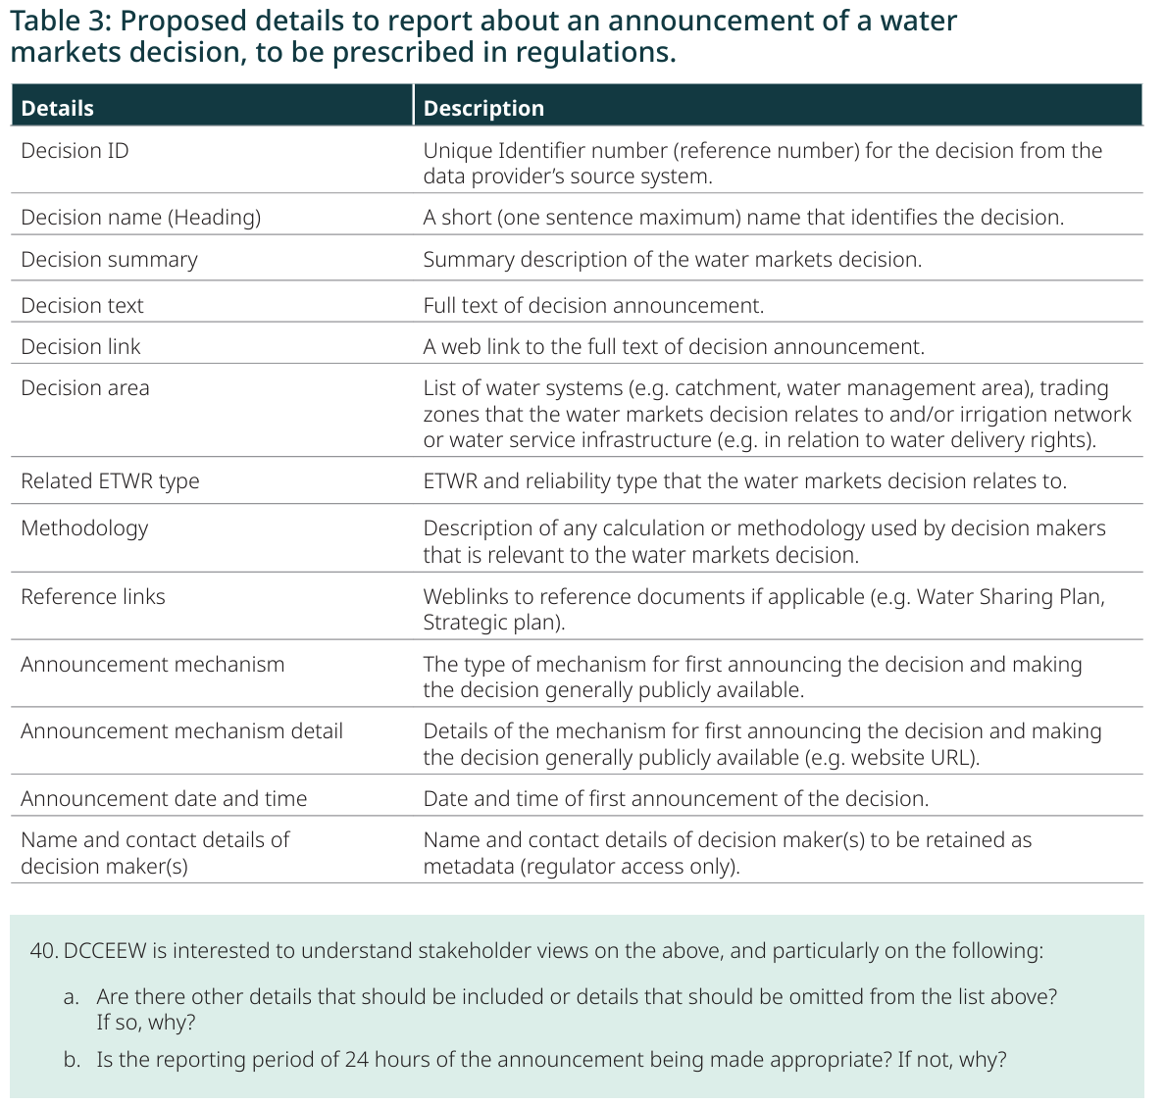

**Position**

See 1.3.

## 1.5. Manner or form for reporting decision information to the Bureau

**Background**

The Bureau is developing a new Water Data Hub which will allow for secure provision of water markets decision information. The Water Data Hub will accommodate several methods for provision of data (manner of provision) via an online data provider portal, which are expected to include:

1. a form or capacity for manual file upload

2. API interface

3. Secure File Transfer Protocol (SFTP).

The form or format of the water markets decision information will need to be such that it can be automatically ingested by the Water Data Hub, appropriate to the manner of provision.

Email not currently considered.

**Position**

* The manner for reporting should capture existing information channels, such as emails where IIOs notify customers of decisions. This would help alleviate the regulatory burden, and ensure notification occurs simultaneously with all parties.
* A central hub is considered to be unnecessary given there are multiple water markets which makes one central site null and void, and users are concerned by the cost implications of this.
* A backup system needs to be available for instances where this site may crash or be malfunctioning, such as an email option.

## 1.6. What records are to be kept?

**Background**

|  |  |
| --- | --- |
| **Legislation** | **Regulation (proposed)** |
| A person who makes a water markets decision will be required to keep the following records in relation to the decision for at least 5 years commencing on the water markets decision date:   1. The fact that the water markets decision was made and the date on which it was made (section 101C(1)(a)), 2. If the water markets decision was provided to the Bureau under section 101B(1)(a) – all the details provided, and the date and time on which the water markets decision was provided (section 101C(1)(b)), 3. If the water markets decision was not announced under section 101B(1)(a) – the date, time, manner and content of the announcement of the water markets decision (section 101C(1)(c)), and 4. any other information as is prescribed by the regulations (section 101C(1)(d)). | It is proposed to also include in the regulations records of the following:   * The name of the person that made the water markets decision, and * If the water markets decision was not announced under section 101B(1)(a):   – all information which is required to be reported, and is reported to the Bureau under section 101B(3), and  – if not otherwise prescribed under Regulations for the purposes of section 101B(3), the date and time on which the decision was reported to the Bureau and the name of the person that reported it. |

**Position**

* Clarify if ‘name of the person’ should be ‘name of the entity’, as a personal names pose privacy concerns.
* See positions for previous sections.

# General

## Timeframe for commencement

The timeframe for these regulations to commence is 1 July 2026.

It is noted that this is after the ongoing major water recovery efforts of the Federal Government.

Given the focus of the Discussion Paper on ‘increasing fair access to market sensitive information’, it is highly distasteful that the regulations only commence after these ongoing Federal Government interventions, which are the ultimate (and perhaps only major) example of misuse of market sensitive information on-scale.

While this date may be in the legislation, it would show good-faith for the Federal Government to be at least acting within the spirit of Part 5 in respecting the handling of market sensitive information.

Instead, we are seeing the Federal Government acting to the contrary. This has been confirmed by a recent report[1] by the Inspector-General of Water Compliance, which made some concerning findings about the handling of market sensitive information by DCCEEW.

Furthermore, the recent tender process has raised major concerns by stakeholders for impacts on water markets. Specifically, the tender documents said:

*‘Only respondents who submit an EOI in this first stage of the multi-stage procurement process are eligible and may be invited to participate in any subsequent requests for tender in 2025, arising from this EOI.’*

*‘Any response under this EOI is non-binding and considered to be an expression of interest only.’*

This concern from stakeholders such as NIC is that this approach will lead to false market signals via a hyper-inflated indication of buybacks interest, in turn, leading to artificially inflated prices. This is because many people will likely submit an EOI in order to keep the option open for the future, who may have little to no intent in actually participating, particularly depending on what the actual prices will be.

This concern was raised by NIC at the time:

*“The Federal Governments processes are inconsistent with their own water market reforms,”*

*“It’s unacceptable to tell people they must ‘get in now, or they’ll miss out’ when we know that is not how the process has to work but in doing so, the Federal Government becomes the ‘sole holder’ of the most comprehensive southern Basin water market information, at the exclusion of all others.”*

*“Most concerning, is this new announcement comes only weeks after a scathing report from the Inspector General of Water Compliance that called out the Federal Government for poor conduct in previous tender approaches.”*

*“Participants need to be confident this is a fair and equitable and that the Federal Government has processes to mitigate market shocks, manage sensitive information and provide good faith negotiations.”[2]*

It is within the context of these repeated and disturbing abuses of market sensitive information that this public consultation is occurring.

# Conclusion

NIC welcomes this public consultation on the regulations to enable operation of requirements in the new Part 5A to the Water Act 2007, relating to the announcement of ‘water markets decisions’.

Overall, NIC is concerned that these regulations go beyond the regulatory-need and impose a significant regulatory-burden that outweighs the benefits.

While NIC supports utmost transparency and fair market participation, this regulation is not fit-for-purpose as it goes beyond what is considered reasonable, is unclear, and is not a proportionate response.

NIC welcomes further consultation on a new version that meets legislative requirements in a fair, reasonable and proportionate manner.

**Ends.**

Member feedback sought – any other issues, comments or recommendations.

1. [Audit - Controls Supporting Complinace with Basin Plan Requirements](https://www.igwc.gov.au/sites/default/files/2024-09/controls-supporting-compliance-basin-plan-requirements.pdf)
2. [Buyback round designed to over-estimate interest ahead of election | National Irrigators' Council](https://www.irrigators.org.au/buyback-round-designed-to-over-estimate-interest-ahead-of-election/)